The Coins of Maqatir
Donald McNeeley

Khirbet el-Maqatir has four occupational phases as established by archaeological evidence: an Amorite Bronze Age fortress, an Israelite occupation from the Iron Age I (IA I), a city from the NT Hellenistic/Roman time, and a Byzantine monastery. First occupied near the end of the Middle Bronze III period (1600-1485 BC), Khirbet el-Maqatir was sporadically occupied until the Byzantine Period (AD 320 - 636). Numismatic evidence assists in defining occupational periods from the Persian Period (539-332 BC) through the Byzantine Period (AD 320 - 636).

While pottery remains the most used means to establish a chronological understanding of a specific site, “coins are among the most helpful archaeological articles for dating purposes when recovered in legible condition.” Khirbet el-Maqatir is blessed with an abundance of coins. This became abundantly clear after 2011 when the antiquities authority changed its policy to allow metal detectors on site. This policy change allowed Ellen Jackson (Figure 1), an excellent metal detectorist, to work on the site, dramatically increasing the number of coins excavated each year. However, just like pottery, it is essential to realize that there is an “important limitation on the use of numismatic (coin) evidence ... we do not know precisely how long coins stayed in circulation.” As stated in the Holman Bible Handbook: “The presence of coins at a site can aid in the dating of the particular strata in which they are found. The layer or stratum cannot be dated earlier than the date of the coin found in it.” But, a date is not the only retrievable data from a coin. Coins can provide information on the cultural aspects of the society that minted the coin. Political, religious, and social concepts have been worthy of being stamped on coins worldwide. Sometimes, images of the current king or ruler are engraved on the coin, as well as wives and other prominent people of the time. Because of these images on the coins, if the coin is from the Roman occupation in the first century AD and is found in good condition, a precise date might be assigned. However, coins struck before this timeframe are assigned a relative date.
Figure 1: Ellen Jackson -Metal Detectorist

The Kirbert el-Maqatir coins were either hidden intentionally or dropped accidentally. These coins then wait patiently for many centuries for the excavator’s trowel. Once excavated, cleaned, and analyzed, the coins assist in explaining the chronology of the site. The graph below (Figure 1) shows the overall distribution of the 690 coins excavated at Kirbert el-Maqatir as of the dig season 2014. The distribution of coins unequivocally supports the NT and Byzantine occupation periods defined from other archaeological evidence (pottery, architecture, C-14 dating, and objects). Once the coins from the 2015 dig season are analyzed, this chart will require an update, but we expect the same general distribution.

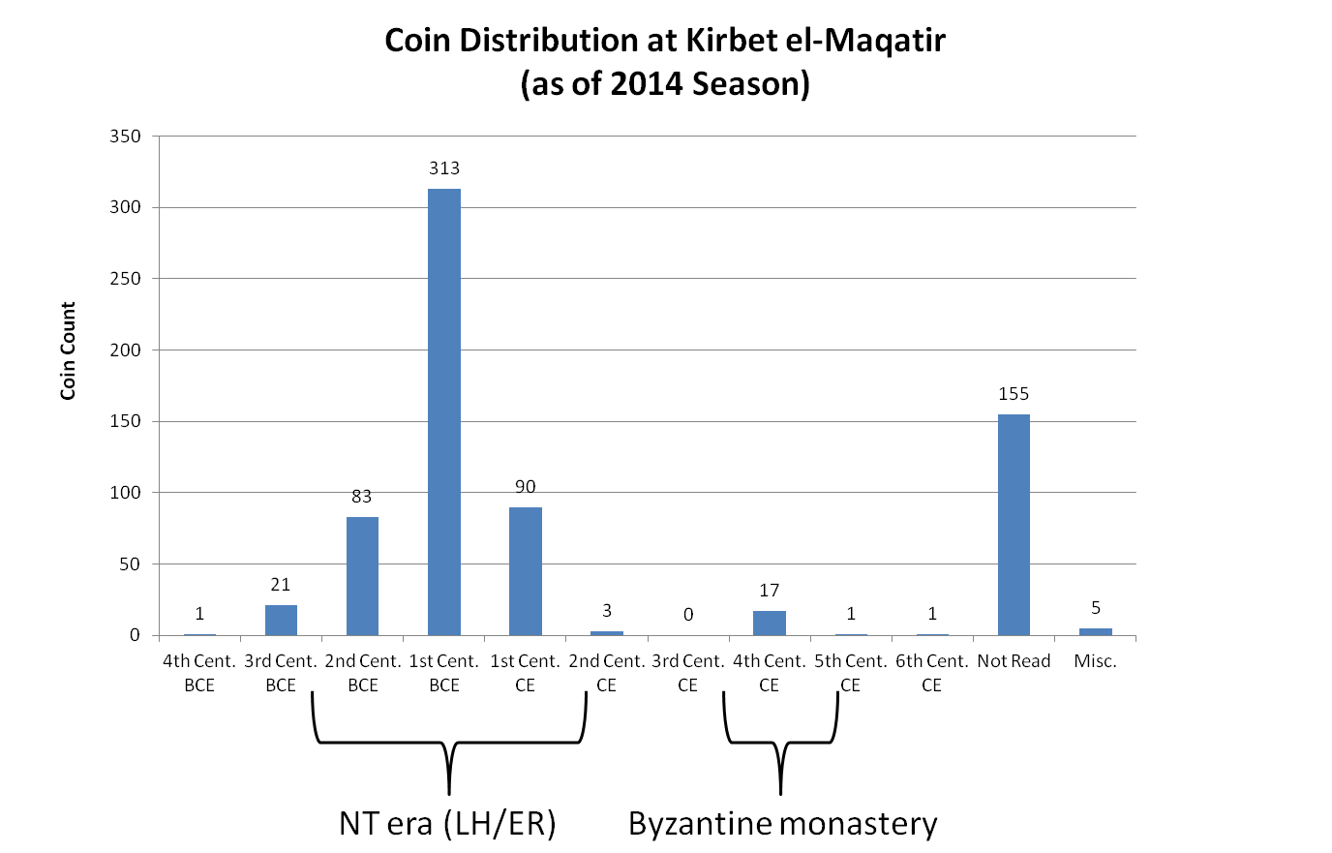
Figure 2: Coin Distribution by Century

However, the earliest coin (Figure 2) excavated thus far was minted in the late Persian Period (4th century BC). Staff numismatist Yoav Farhi identified that the coin was minted during the Late Persian Period and is one of the Yehizkayah coins (A Treasury of Jewish Coins (TJC) reference number 24). This information can extend backward in time the occupational times, especially when combined with a partial Persian period lamp and a piece of Persian-era jewelry excavated in 2014. The coin, lamp, and jewelry may indicate a minimal occupation of this site in the Persian era, but more excavation and analysis is required. Interestingly, coins began to be used for commerce during the Persian Period. But, typically, only independent states could mint coins, while in some cases, where there was limited autonomy, the local authorities could mint coins. Finding Israelite-minted coins from the Persian Period would change our understanding of the site. Unfortunately, as of the end of the 2014 season, no Israelite-minted coins have been found.

Figure 3
This coin (Figure 3), minted during the Later Persian Period, is in reasonably good shape for being in the ground for so long.

As the Associates for Biblical Research (ABR) continues, the excavations are Maqatir, and the staff and volunteers will look for two coin types. First, coins “bearing Hebrew script from the middle of the 4th century BC bearing the legend Yahud, the name of the province of Judea in the Persian period.” Secondly, the staff and volunteers will look for oval-shaped gold darics. These coins were minted during the reign of Darius the Great (Darius I of Persia, 521–486 BC), who sponsored the minting of coinage in Palestine. On these darics, the obverse (front side), there will be “depicted the Persian king robed and crowned, facing right, and kneeling with his left knee up and his right knee down. In his left hand, he held a bow, and in his right, a long arrow or lance. All Persian imperial coins’ reverse (back side) carried no markings.”

The following table illustrates the remaining chronology of the Maqatir coins. By reading from left to right, the first column provides the archaeological period when the coins’ minting occurred, followed by each coin type (generally named after the king who authorized the minting). Next are specific times when the coins were minted; the total coins follow this for that coin type (as of 2014). Finally, a picture of some significant coin(s) associated with the archaeological periods is shown.

Period | Coin Type Names | Timeframe |  | Number Coins |  |  | Representative Coins of Period
Persian Period | Yehizkayah | 550-329 BC |  | 1 |  |  | Above: Yehizkayah  From Maqatir
Early Hellenistic (332-198 BC) | Ptolemy II | 285–246 BC |  | 4 |  |  | 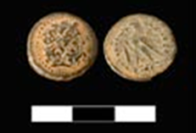  Above: Ptolemy II  From Maqatir
 | Ptolemy III | 246–221 BC |  | 1
 | Antiochus III | 223–187 BC |  | 17
 | Indeterminate | 332-198 BC |  | 2
Late Hellenistic (198-63 BC) | Seleucus IV | 187–175 BC |  | 1 |  |  | Above: Antiochus IV  From Maqatir
 | Antiochus IV | 175-164 BC |  | 14
 | Demetrius I | 162–150 BC |  | 4
 | Antiochus VII | 138–129 BC |  | 2
 | Hasmonean | 167-63 BC |  | 24 |  |  | Above: John Hyrcanus I  From Maqatir
 | John Hyrcanus I | 135–104 BC |  | 12
 | Demetrius II | 145–141 BC & 129–125 BC |  | 2
 | Ptolemy X Alexander I | 107–88 BC |  | 1 |  |  | 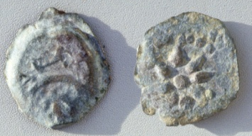  Above: Alexander Jannaeus  From Maqatir
 | Alexander Jannaeus | 104–76 BC |  | 316
 | Indeterminate | 198-63 BC |  | 9 |  |  | 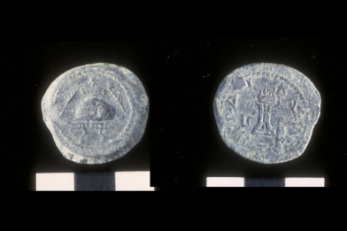  Above: Herod I  From Maqatir
Early Roman (63 BC - AD 135) | Mattathias Antigonus | 40–37 BC |  | 2
 | Herod I | 37–4 BC |  | 15
 | Aretas IV | 9 BC–AD 40 |  | 1
 | Herod Archelaus | 4 B.C.–A.D. 6 |  | 1
 | Valerius Gratus | AD 15–26 |  | 6 |  |  | Above: Pontius Pilate  From Maqatir
 | Pontius Pilate | AD 26–36 |  | 3
 | Agrippa I | AD 37–44 |  | 7
 | Festus | AD 60–62 |  | 3 |  |  | Above: Festus  From Maqatir
 | Antonius Felix | AD 52–60 |  | 3
 | Porcius Festus | AD 59–60 |  | 1
 | Jewish Revolt | AD 66–70 |  | 45 |  |  | Above: Jewish Revolt  From Maqatir
 | Marcus Ambibulus | AD 70 |  | 2
 | Tyre | AD 73 |  | 1
 | Trajan | AD 98–117 |  | 2
 | Indeterminate | 63 BC - AD 135 |  | 21
Early Byzantine (AD 324-491) | Theodosius I | AD 379-383 |  | 5 |  |  | 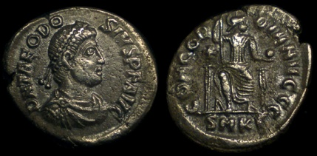  Above: Theodosius I  From website
 | Early Byzantine III | AD 392-450 |  | 4
 | Early Byzantine IV | AD 450-491 |  | 13
 | Indeterminate | AD 324-491 |  | 3
Late Byzantine (AD 491-640) | Late Byzantine | AD 491-640 |  | 1
Modern | Modern coins |  |  | 5
In Process | Being processed and analyzed |  |  | 135
 |  |  | Total coins |  | 690

Occupational History Based on the Numismatics: A Recap

As readily seen from the table, there is only one Maqatir coin before the Early Hellenistic Period. As already noted, additional excavation and research is required before any definitive statement concerning the Persian occupation at Maqatir. However, coins from the Early Hellenistic period (332-167 BC) featuring Ptolemy II Philadelphus (285–246 BC) and Ptolemy III (246–221BC) have been identified on the site, as have Antiochus III (223–187 BC) coins. With over 75% of this period’s coins associated with Antiochus III (223–187 BC), one is tempted to look for some historical reason. When Antiochus III defeated the Ptolemies at the battle of Paneas, the Land of Israel passed to Seleucid dominion. This rulership transfer might indicate the establishment an initial village settlement c. 200 BC near the end of the Early Hellenistic Period. However, as noted above, minimal occupation from the Persian and Ptolemaic periods is possible. But, the magnitude of the Seleucid coins suggests that something happened. From the coin evidence, this village continued to exist through the Late Hellenistic (LH) Period (198-63 BC) and into the Early Roman (ER) Period (63 BC-AD 69) for a total of 269 years. The demise of this city occurred during the third year of the First Jewish Revolt against Rome (AD 68/69) based on other archaeological evidence and the sudden absence of coins after AD 69.

Between the time of the city’s demise and the next occupant, the site was vacant for 315 years. The Byzantine coinage from Maqatir suggests that the site was re-occupied during the reign of Theodosius I (AD 383 - 395), and a memorial basilica and monastery was built on the summit above the old LH/ER city. But this is another story.

I invite you to come to Israel and work with the archaeological team as we collectively learn more about the occupants of the site through the coins, but also all other artifacts (pottery, objects, architecture, etc.).

BIBLIOGRAPHY

Achtemeier , Paul J. Harper & Row and Society of Biblical Literature, Harper’s Bible Dictionary (San Francisco: Harper & Row, 1985).

Borowski, Oded. “From Shekels To Talents: Money In The Ancient World.” Bible and Spade (1994).

Betlyon , John Wilson. “Guide To Artifacts: Numismatics and Archaeology.” Biblical Archaeologist (American Schools of Oriental Research, 1985).

Dockery, David S., Trent C. Butler, Christopher L. Church, Linda L. Scott, Marsha A. Ellis Smith, James Emery White, and Tenn.) Holman Bible Publishers (Nashville. Holman Bible Handbook. Nashville, TN: Holman Bible Publishers, 1992.

Elwell, Walter A., and Barry J. Beitzel. Baker Encyclopedia of the Bible. Grand Rapids, MI: Baker Book House, 1988.

Farhi, Yoav. “Numismatic Report,” in Khirbet el-Maqatir 2014 Excavation Report, edited by Scott Stripling, (Akron, PA: Associates for Biblical Research, 2014.

Negev, Avraham. The Archaeological Encyclopedia of the Holy Land. New York: Prentice Hall Press, 1990.

VanderKam, James C. The Dead Sea Scrolls Today. Grand Rapids, MI: Eerdmans, 1994.

Paul J. Achtemeier, Harper & Row and Society of Biblical Literature, Harper’s Bible Dictionary (San Francisco: Harper & Row, 1985), 1091.
James C. VanderKam, The Dead Sea Scrolls Today (Grand Rapids, MI: Eerdmans, 1994), 21.
David S. Dockery et al., Holman Bible Handbook (Nashville, TN: Holman Bible Publishers, 1992), 69.
John Wilson Betlyon, "Guide To Artifacts: Numismatics and Archaeology." Biblical Archaeologist (American Schools of Oriental Research, 1985).
Yoav Farhi, "Numismatic Report," in Khirbet el-Maqatir 2014 Excavation Report, ed. Scott Stripling (Akron, PA: Associates for Biblical Research, 2014), 127-139.
Oded Borowski, "From Shekels To Talents: Money In The Ancient World." Bible and Spade (1994): 110–114.
Avraham Negev, The Archaeological Encyclopedia of the Holy Land (New York: Prentice Hall Press, 1990).
Walter A. Elwell and Barry J. Beitzel, Baker Encyclopedia of the Bible (Grand Rapids, MI: Baker Book House, 1988), 485.

